**Hypothesis Testing:**

The male employment rate is quite higher as compared to the female employment rate.

Null Hypothesis (Ho): Male employment is higher than the female employment rate.

Alternative Hypothesis (Ha): Male employment rate is lesser than the female employment rate.

Initial boxplot for data visualization:

A screenshot of a cell phone

Description generated with very high confidence

From the above plot, there is a gender bias when it comes to hiring people. But we can further validate it by performing the Z-test as follows:

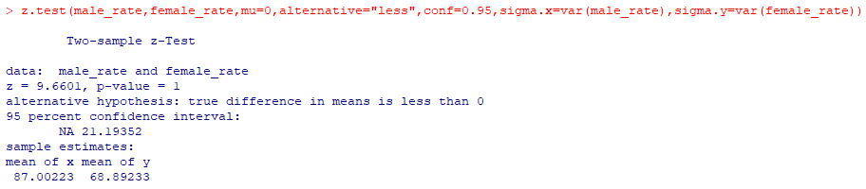

Performed the two-sample hypothesis testing at a 95% confidence level in R. Used Z-test to validate the hypothesis. As it can be observed, that the p-value = 1, which is greater than 0.05, we accept the null hypothesis.